

**Project 2:**

Convolutional and Recurrent Neural Networks

CZ4042 Project report

*by Hans Albert Lianto (U1620116K) and Eko Edita Limanta (U1620574A)*

Nanyang Technological University, AY2019-2020 Semester 1

# Project 2A: Object Recognition

## Introduction­­

In this section, different architectures for a convolutional neural network will be trained to predict the label from the first batch of CIFAR-10 dataset. There are 10,000 training samples and 2,000 test samples.

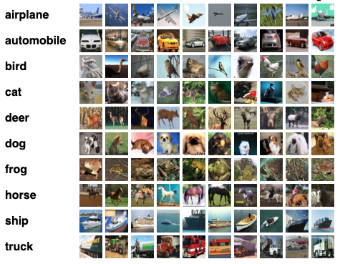

*A simple visualization of CIFAR-10 dataset*

## Methods

A convolutional neural network is designed with the following layers:

* An Input layer of 3x32x32 dimensions
* A convolution layer 𝐶1 of 50 filters of window size 9x9, VALID padding, and ReLU neurons.
* A max pooling layer 𝑆1 with a pooling window of size 2x2, with stride = 2 and padding = 'VALID'.
* A convolution layer 𝐶2 of 60 filters of window size 5x5, VALID padding, and ReLU neurons.
* A max pooling layer 𝑆2 with a pooling window of size 2x2, with stride = 2 and padding = 'VALID'.
* A fully connected layer 𝐹3 of size 300.
* A softmax layer 𝐹4 of size 10.

Here is an illustration of the architecture, similar to the one in lecture notes.

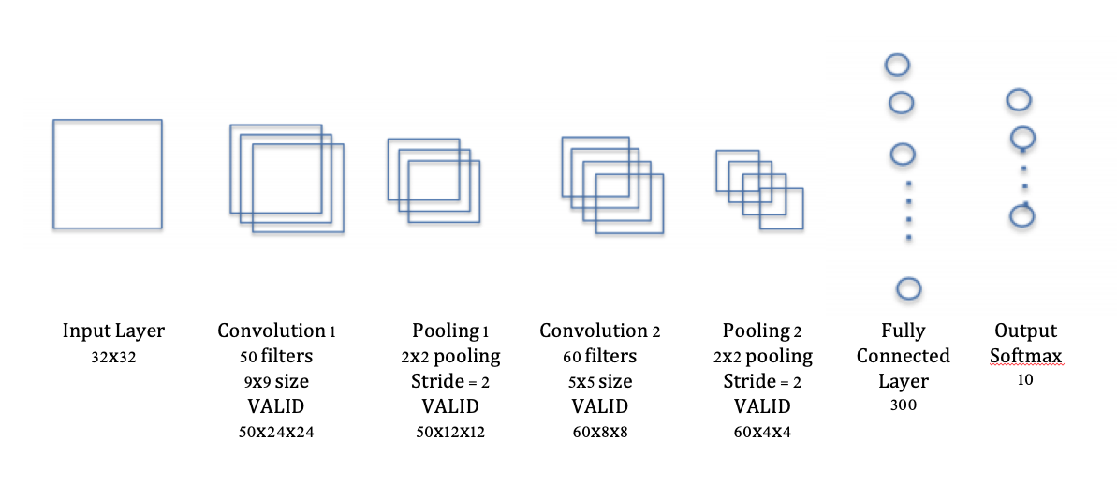

This is the convolutional neural network that will be used across the experiments.

In the experiments, different methods are used to train the convolutional neural networks and compare the results. Various hyperparameters such as learning rate, the number of feature maps, and number of features will be optimized. Other training methods are tried after discovering the optimal number of filters.

## Experiments and Results

### Pre-processing

Before the experiment, the training dataset is split with ratio 9:1; 90% of the data is used for training and 10% for validation respectively. The validation set to find optimal hyperparameters in the convolutional loop.

Furthermore, the features in all the dataset partitions (training, testing, validation) are normalized to prevent dominance of dimensions. The images were scaled using the formula:

After the training, the test dataset will be used to measure the accuracies of the trained models.

### Initial Training of CNN using Mini-batch Gradient Descent

The CNN mentioned above is trained using mini-batch gradient descent learning with batch size of 128 and learning rate 𝛼 = 0.001. The model is run for 1000 epochs with the training cost and validation cost being measured at each epoch.

The result is as follows:

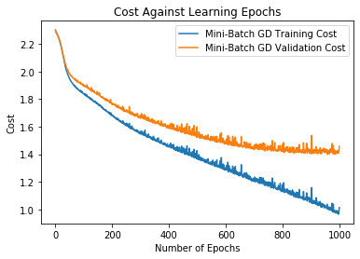

Here, it is observed that at around 100 epochs, the training cost and validation cost start to diverge. The rate of decrease of the validation cost also decreases as training progresses. Above 800 epochs, the validation cost is almost constant or even increasing.

With this observation, early stopping will be implemented in the next experiment. The idea is to prevent overfitting by stopping the training when validation loss starts to increase even when training loss is still decreasing. With this, the number of epochs of training is set to be 800. Number of epochs means the number of times the model has gone through the training data.

Using early stopping at 800, the test accuracy vs epoch graph is plotted and shown in the next page.

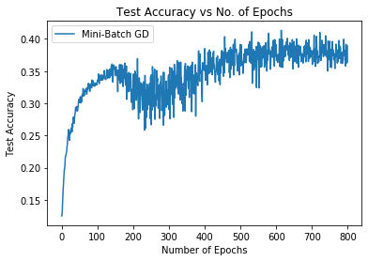

It is observed that the test accuracy stagnates and using early stopping mechanism, saving a significant amount of training time.

Next, the feature maps at both convolution layers and pooling layers when some of the test patterns/images are run through the network are visualized.

Weights learned at convolution layer 1 C1:

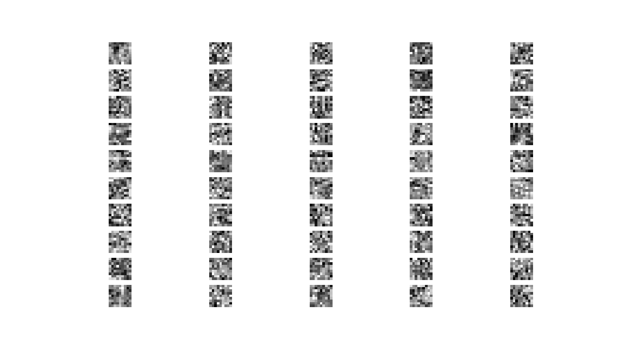

Test Pattern 1:

Project%202/Part%20A/Q1/figures/1b_1.png

Feature map at convolution layer 1 C1:

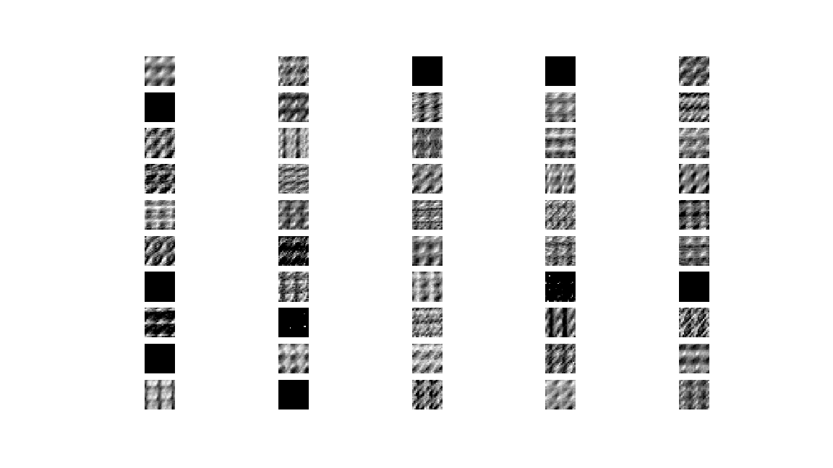

Pooling Layer S1:

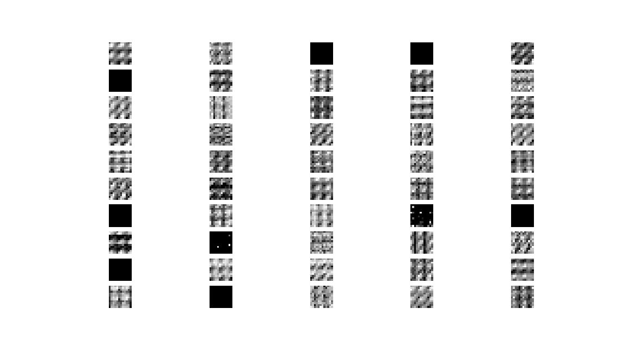

Feature map at convolution layer 2 C2:

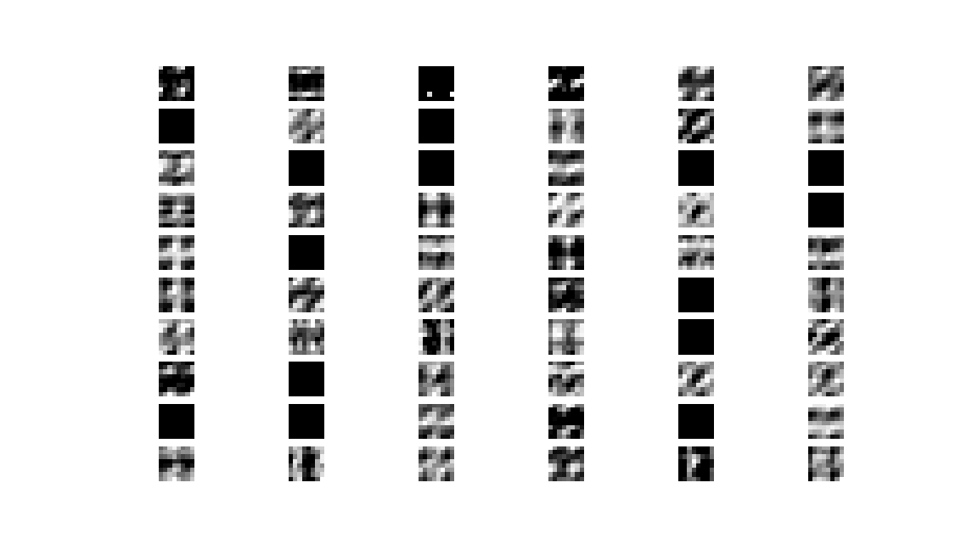

Pooling Layer S2:

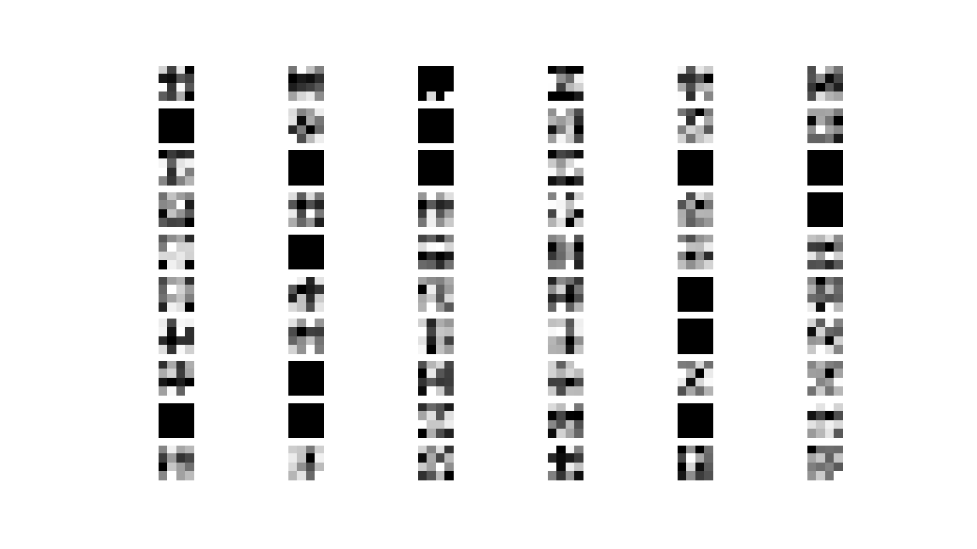

Using test pattern 2:

Project%202/Part%20A/Q1/figures/1b_2.png

Feature map at convolution layer 1 C1:

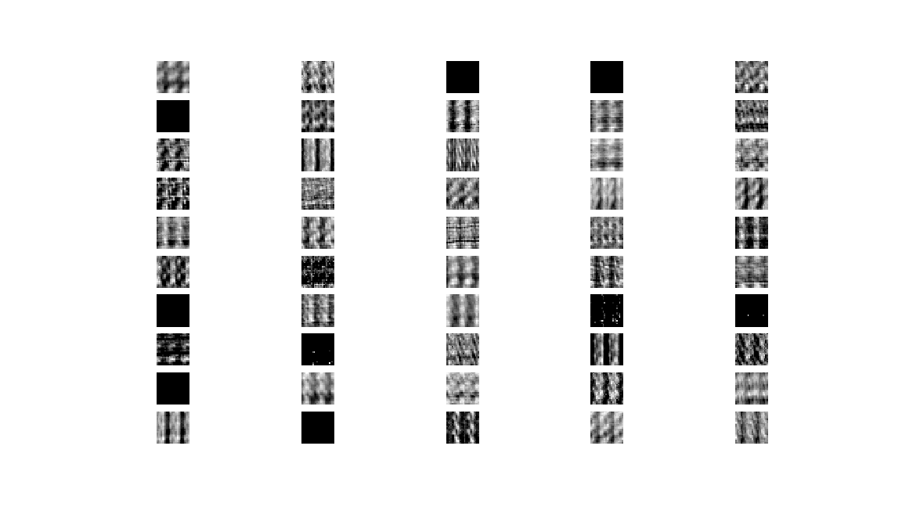

Pooling Layer S1: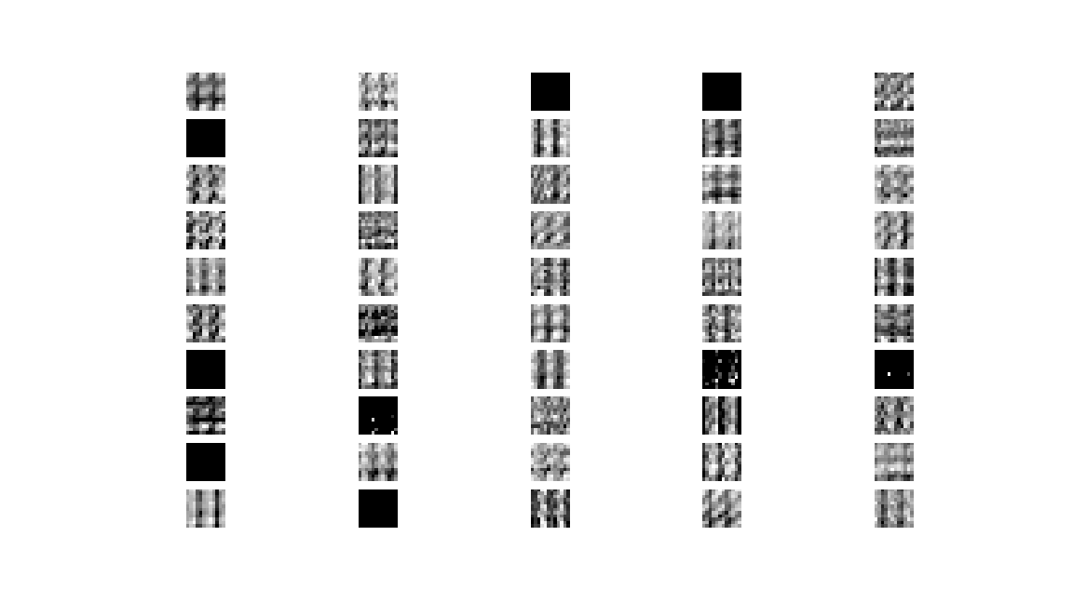

Feature map at convolution layer 2 C2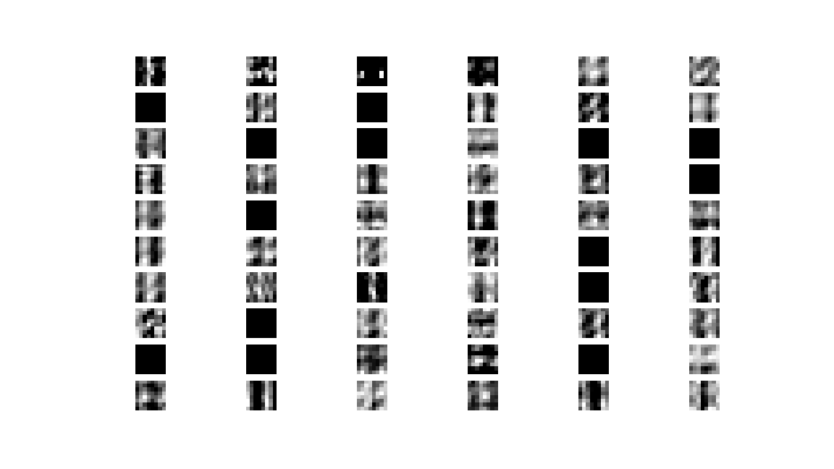

Pooling Layer S2:

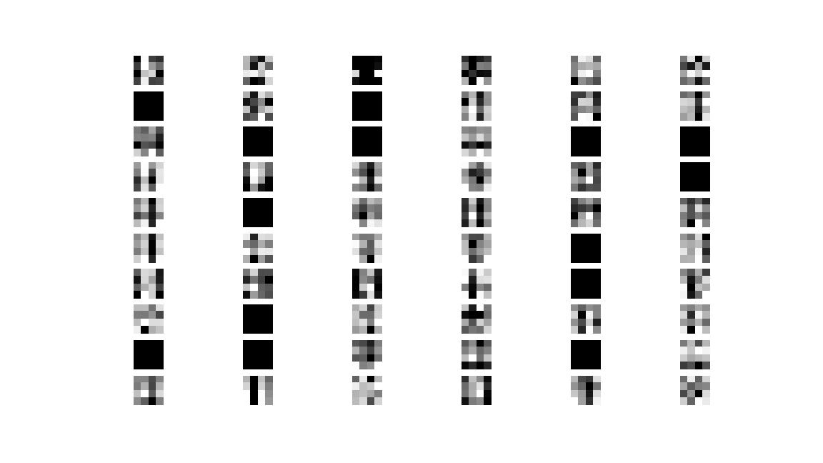

From the feature maps, one can see that the weights learned at the first convolutional layer are not meaningful/the features ‘illustrated’ by the feature maps only respond well to simple patterns. It does not respond well enough to patterns complex enough to be able to recognize animals from the CIFAR dataset. Hence a low 40% model accuracy at the end of the training is expected or reasonable. Even if the number of epochs is increased up to 1000, the accuracy of the model does not improve significantly.

To summarize the possibilities for this observation/low model accuracy:

* The dataset is too complex for the model (i.e. the model is too simple for the dataset; underfitting). This may be because of the complex features across classes which exist in the CIFAR-10 dataset.
* Dataset uses a 3-colour channel, which may increase complexity further.
* Only one batch of the CIFAR-10 dataset is used; hence a less accurate model is obtained at the end of training. Using more training data will make the model generalize better.

### Finding the Optimal Number of Feature Maps using Grid Search

Next, a grid search is used to find the optimal numbers of feature maps at the convolutional layers. Test accuracy will be used to determine the optimal numbers.

Here, several combinations of hyperparameters are used for grid search at both C1 and C2. This have been selected by choosing a few nearest neighbours after each round. Some of the hyperparameters are listed as follows:

hyper\_parameter = [(10,30), (50,50), (80, 80)]

hyper\_parameter = [(80,80), (80,85), (80, 90), (85,90), (90,90)]

The first set of hyperparameters are tried. For the first round, the following results are obtained:

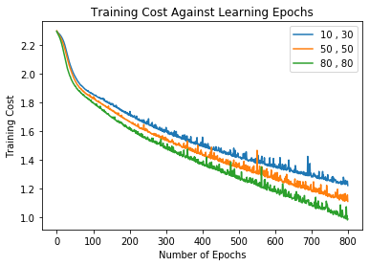

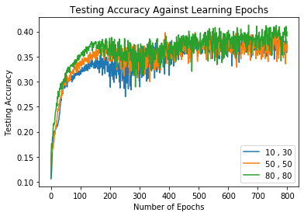

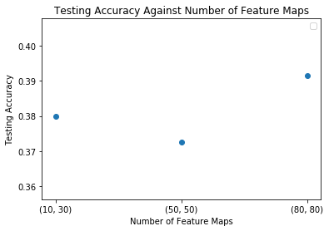

It is observed that the best testing accuracy is obtained when the number of feature maps is (80, 80). This result is expected as there are more convolutional filters, the model is more complex, and hence the training cost will be lower.

Next search is around (80, 80) as it gives the best testing accuracy. The results are as follows:

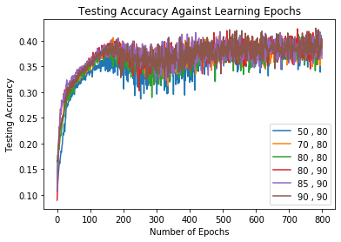

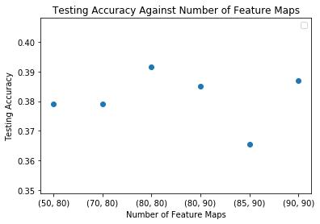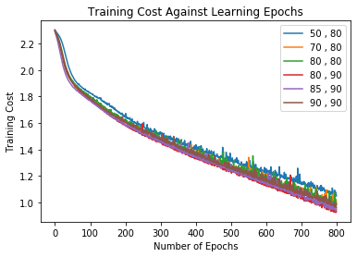

After the second search, it is observed that the best number of feature maps is around 80-90. Another grid search is performed around this figure. The result is as following:

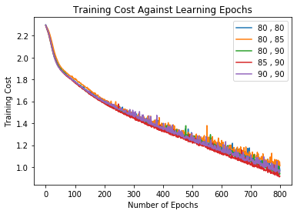

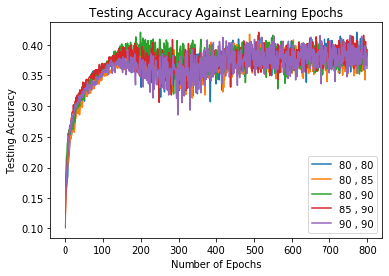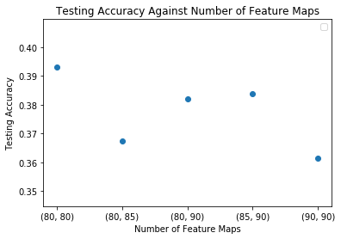

As observed above, the best optimal number of feature maps for this CNN model is (80, 80).

### Further Experiments with CNN Architecture with Learning Rate, Momentum and Dropout

In the next part, the optimal number of filters (80, 80) are used to train the network using different methods:

* Using gradient descent with momentum with the momentum term = 0.1
* Using RMSProp algorithm for learning
* Using Adam optimizer for learning
* Adding dropout to the layers

Here are the results of the trainings:

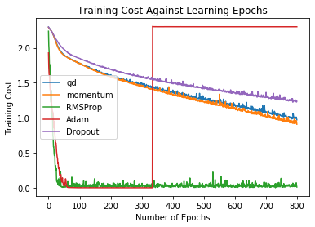

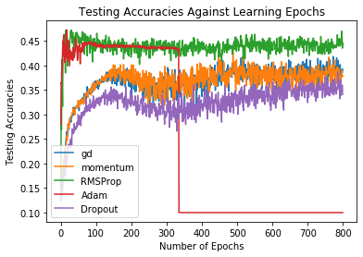

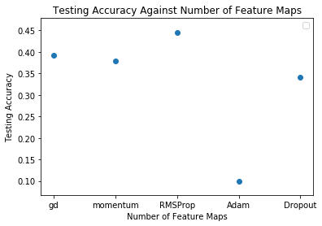

Based on the results, it is observed that the CNN using RMSProp has the best performance in terms of training loss and testing accuracy. It also converges faster than other methods.

There is a strange anomaly in the Adam optimizer graph. It is possible that when the Adam optimizer is close to optimal, the moving average of squares of gradients can become extremely small. This causes its inverse to become extremely large, causing spikes in the graph (due to extremely large updates during gradient descent that cause the gradients to diverge away from the minima instead of converging within it).

One way to prevent this is to reduce the learning rate. Another round of training is run with Adam optimizer using a learning rate lower by a power of 10, keeping the other methods the same as before. The result is as follows:

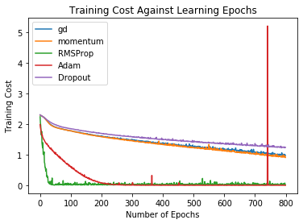

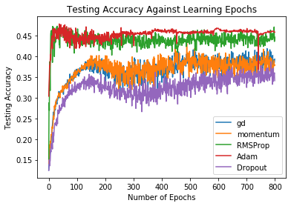

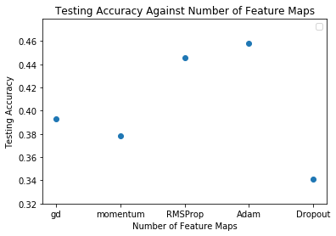

From the figures above, it is observed that the anomaly in result for the CNN trained with the Adam optimizer has disappeared. This is because of the reason previously discussed above no longer occurred. The CNN trained using the Adam optimizer now has the best accuracy; this is expected as the learning rate is now much lower.

### Comparison of Previous Models

After all the experiments, the performances of the models from the previous three sections are compared.

In part (1), the model is trained using mini-batch gradient descent. It is observed from the result above that the test accuracy of the final model is not very good at 40%. One of the factors causing this is clearly because the complexity of the CIFAR-10 dataset. The model is not complex enough to yield higher accuracy. There are many complex features across the CIFAR-10 dataset, and this is further amplified by 3-colour channels used.

In part (2), the optimal number of feature maps is found training the model in the grid search algorithm. A model accuracy higher than that of part (1) is obtained as the number of filters are increased, due to the model’s increasing complexity. However, the improvement is not very significant. Also, due to the small training dataset, overfitting could be possible.

During the experiment, the CNN is trained with hyperparameter (90, 90) but it an out-of-memory error is thrown. This error still occurs even if the code is running in a Google Colab GPU environment. Initially, a small number of features for the initial layers are used for training. This is so that the model can detect more complex structures as the number of features are increased. If many features are used at the beginning, it will not be manageable in the later layers.

In part (3), the model is trained again using multiple optimization algorithms. Using these possible optimization methods, better results are obtained, especially using Adam optimizer and RMSProp for learning. Mini-batch gradient descent does not work well with CIFAR-10 dataset as it tends to oscillate near the optimum, causing a slow convergence rate. Mini-batch gradient descent also reduces the variance of individual patterns and achieves stable convergence, but at the expense of true minimum of the complex error profiles. This works against the CIFAR-10 dataset as it has very complex error profiles.



The best results are obtained using RMSProp given the optimal number of feature maps according to the experiments performed. This method uses exponentially decaying average to decay from extreme gradients. Comparatively, using Adam optimizer with lower learning rate gives better test accuracies but converges slower than RMSProp.

## Conclusions

In this part-project, different CNN architectures are used to classify animals in part of the CIFAR-10 dataset, with relatively poor results (i.e. low model accuracies) due to the sheer complexity of the CIFAR-10 dataset/classification problem and the fact that only part of the dataset is used. Moreover, the convolutional layer model used is also not deep/complex enough to be able to classify the CIFAR-10 dataset properly.

From all the training performed, the model performances/accuracies obtained are relatively low (40%-50%) even after using optimization methods. In comparison, there are models which can get up to 80% accuracies on this same dataset. But the models are much more complex; moreover, these models are trained using the full CIFAR-10 dataset.

Here are some possible improvements for the current model:

* Use the full CIFAR-10 dataset
* Increase the number of convolution and pooling layers (increase model complexity)
* Use cross-validation techniques along with optimization algorithm such as Adam optimizer and RMSProp
* Use more fully connected layers at the end of the model instead of one

# Project 2B: Text Classification

## Introduction

A dataset containing Wikipage entries and labels (0-14) that indicate what category the Wikipage belongs to is given.

Information regarding the dataset is given below:

|  |  |
| --- | --- |
| **train\_medium.csv** | **test\_medium.csv** |
| **No of entries in dataset** = 5600 | **No of entries in dataset** = 700 |
| **No of possible output classes** = 15  Only the first 100 letters/words are fed into the model. | |

Visualization of a fragment *(10 tuples)* of the training dataset is shown below:

In this part-project, convolutional and recurrent neural network architectures will be used to train the model to classify the category of a Wikipage based on the Wikipage article title (input encoded at the character-level) and on the article’s first paragraph content (input encoded at the word-level). Different types of architectures and experiments will be performed on both the CNNs and RNNs to see how to optimize or what would improve each architecture’s test accuracy—these will involve using dropout, and in the RNN case, gradient clipping, multiple cell/neuron layers and the RNN cell type used (i.e. LSTM, GRU, Vanilla [BasicRNNCell])

## Methods

### Character-level Encoding for Character Classifiers

When **train\_medium.csv** and **test\_medium.csv** are read for the character classifiers used in this part-project, the second row of the input file (which contains the Wikipage article title) is processed as follows:

1. A **TensorFlow ByteProcessor** encoder is created that encodes the first 100 (MAX\_INPUT\_LENGTH = 100) characters in the second row.

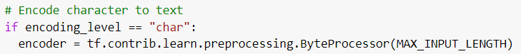

1. The contents of the second row are encoded with this encoder to form an input tensor of size (INPUT\_DATASET\_SIZE [5600 for train and 700 for test], 100) to be fed into the CNN or RNN model.

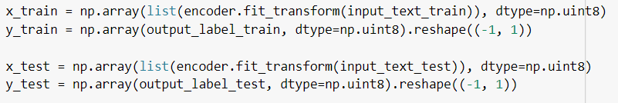

### Word-level Encoding for Word Classifiers

When **train\_medium.csv** and **test\_medium.csv** are read for the word classifiers used in this part-project, the third row of the input file (which contains the Wikipage article’s first paragraph text content) is processed as follows:

1. A **TensorFlow VocabularyProcessor** encoder is created that encodes the first 100 (MAX\_INPUT\_LENGTH = 100) words in the third row.



1. The contents of the third row are encoded with this encoder to form an input tensor of size (INPUT\_DATASET\_SIZE [5600 for train and 700 for test], 100) to be fed into the CNN or RNN model.



### Seed initialization for predictable pseudo-randomness

The seed for initializing weights and biases for the model are always the **same**; so, every time training is run, the initial weights and biases are the same. This causes initialization to be predictable so that the only factor causing training to run differently is solely in the change of hyperparameters. In addition, the seed for shuffling the dataset for mini-batch stochastic gradient descent is also kept the same at the beginning of each training. This causes the script to return consistent results every time it is run.

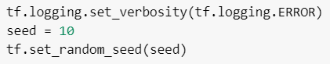

### Training using Mini-batch Stochastic Gradient Descent

When training, mini-batch stochastic gradient descent will be used with a batch size of 128. The output of each model is passed through a final softmax layer, before its softmax cross-entropy is computed. This entropy will be the quantity TensorFlow’s optimizer will minimize. The learning rate for training used is 0.05, and the network is trained for 100 epochs. During each training, the test accuracy (1 - misclassification rate) and “train” entropy at the end of each epoch will be recorded. In addition, the “training” accuracy (1 - misclassification rate) (accuracy computed when the training dataset is fed into the feed\_dict) and the “test” entropy (entropy computed when the test dataset is fed into the feed\_dict) are also recorded at each epoch. The initial networks trained in Section 1 and 2 will have their trainings timed using **time.time()** and compared in Section 5.

### CNN Network Architectures Used

The table below outlines the CNN network architectures used, alongside the section where the network architecture is mentioned in the report:

|  |  |
| --- | --- |
| **Character-CNN**  **[Section No. 1]** | **Word-CNN**  **[Section No. 2]** |
| **Convolution Layer 1**  10 filters of window size 20 x 256  VALID padding  ReLU neurons  **Max Pooling Layer 1**  Pooling window with size 4 x 4  Stride = 2  SAME padding  **Convolution Layer 2**  10 filters of window size 20 x 1  VALID padding  ReLU neurons  **Max Pooling Layer 2**  Stride = 2  SAME padding | **Convolution Layer 1**  10 filters of window size 20 x 20  VALID padding  ReLU neurons  **Max Pooling Layer 1**  Pooling window with size 4 x 4  Stride = 2  SAME padding  **Convolution Layer 2**  10 filters of window size 20 x 1  VALID padding  ReLU neurons  **Max Pooling Layer 2**  Stride = 2  SAME padding |
| **Character-CNN with Dropout**  **[Section No. 5]** | **Word-CNN with Dropout**  **[Section No. 5]** |
| Same architecture as Character-CNN, but Dropout rates of 0.2 (0.2 chance of a neuron being dropped) applied to each conv-pool layer. | Same architecture as Word-CNN, but Dropout rates of 0.2 (0.2 chance of a neuron being dropped) applied to each conv-pool layer. |

### RNN Network Architectures Used

The table below outlines the RNN network architectures used, alongside the section where the network architecture is mentioned in the report:

|  |  |
| --- | --- |
| **Character-RNN**  **[Section No. 3]** | **Word-RNN**  **[Section No. 4]** |
| GRU Layer  Hidden-layer size = 20 | Word vectors passed to **embedding** layer of size 20 before being fed to RNN.  GRU Layer  Hidden-layer size = 20 |
| **Character-RNN with Dropout**  **[Section No. 5]** | **Word-RNN with Dropout**  **[Section No. 5]** |
| Same architecture as Character-RNN, but a Dropout rate of 0.2 is applied to the RNN layer. | Same architecture as Word-RNN, but a Dropout rate of 0.2 is applied to the RNN layer. |
| **Character-RNN with Vanilla Cell**  **[Section No. 6a]** | **Word-RNN with Vanilla Cell**  **[Section No. 6a]** |
| Vanilla (BasicRNNCell) Cell Layer  Hidden-layer size = 20 | Word vectors passed to **embedding** layer of size 20 before being fed to RNN.  Vanilla (BasicRNNCell) Cell Layer  Hidden-layer size = 20 |
| **Character-RNN with LSTM Cell**  **[Section No. 6a]** | **Character-RNN with LSTM Cell**  **[Section No. 6a]** |
| LSTM Cell Layer  Hidden-layer size = 20 | Word vectors passed to **embedding** layer of size 20 before being fed to RNN.  LSTM Cell Layer  Hidden-layer size = 20 |

|  |  |
| --- | --- |
| **2-layer Character-RNN**  **[Section No. 6b]** | **2-layer Word-RNN**  **[Section No. 6b]** |
| GRU Layer  First hidden-layer size = 20  Second hidden-layer size = 20 | Word vectors passed to **embedding** layer of size 20 before being fed to RNN.  GRU Cell Layer  First hidden-layer size = 20  Second hidden-layer size = 20 |
| **Character-RNN with Gradient Clipping**  **[Section No. 6c]** | **Word-RNN with Gradient Clipping**  **[Section No. 6c]** |
| GRU Layer  Hidden-layer size = 20  Gradient clipping threshold = 2 | Word vectors passed to **embedding** layer of size 20 before being fed to RNN.  Gradient clipping threshold = 2 |

## Experiments and Results

### Character CNN Classifier

The regular Character-CNN classifier outlined above is trained. Below is the classifier’s entropy cost, a plot of the training and test accuracy vs epoch number, and the final entropy costs and accuracies of the model:

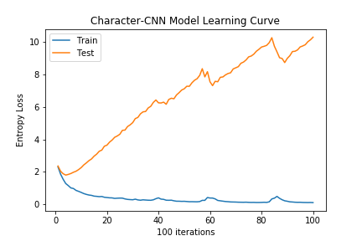 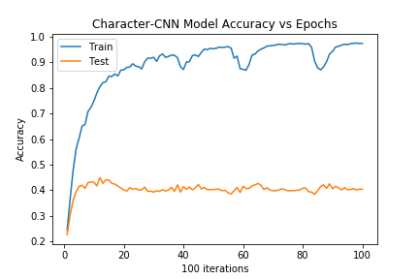

|  |  |  |
| --- | --- | --- |
|  | Dataset used | |
| Train | Test |
| Final accuracy | 0.974 | 0.404 |
| Final entropy loss | 0.0956 | 10.3 |

Notice that though the entropy on training data generally decreases and converges to nearly zero, the entropy on testing data increases after less than 10 epochs, indicating that the network has **overfit** the training set. This is further proven by the training accuracy being far higher than the testing accuracy in the accuracy vs epochs plot.

The regular character-CNN classifier may not be a good ‘fit’ network for the test dataset. Regularizing techniques such as dropout or finding other features to classify paragraph content to category may be needed instead.

### Word CNN Classifier

The regular Word-CNN classifier outlined above is trained. Below is the classifier’s entropy cost, a plot of the training and test accuracy vs epoch number, and the final entropy costs and accuracies of the model:

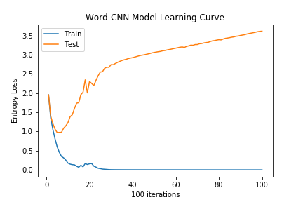 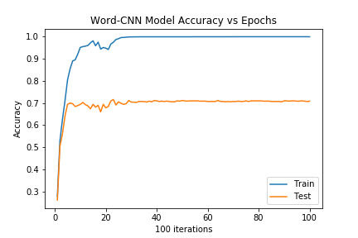

|  |  |  |
| --- | --- | --- |
|  | Dataset used | |
| Train | Test |
| Final accuracy | 0.999 | 0.709 |
| Final entropy loss | 4.77 x 10-4 | 3.61 |

Notice that though the entropy on training data generally decreases and converges to nearly zero, the entropy on testing data increases after less than 10 epochs, indicating that the network has **overfit** the training set. This is further proven by the training accuracy being far higher than the testing accuracy in the accuracy vs epochs plot.

The regular word-CNN classifier may also not be a good-enough ‘fit’ network for the test dataset. Regularizing techniques such as dropout or finding other features to classify paragraph content to category may be needed instead. In addition, a CNN is not appropriate to fit this dataset. This is because the dataset is sequential data and is temporal in nature. A convolutional neural network exploits features within local regions of the dataset, which is more appropriate for image data. A **recurrent** neural network is a more appropriate network to classify this data, since it exploits the temporal nature of the paragraph data (outputs of data at sequence T depends on previous sequences (i.e. 1, 2, …, T – 1)). This reasoning also applies to the Character-CNN classifier.

### Character RNN Classifier

The regular Character-CNN classifier outlined above is trained. Below is the classifier’s entropy cost, a plot of the training and test accuracy vs epoch number, and the final entropy costs and accuracies of the model:

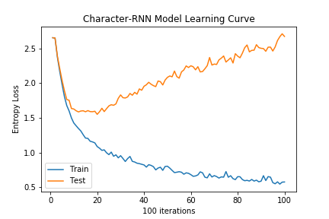 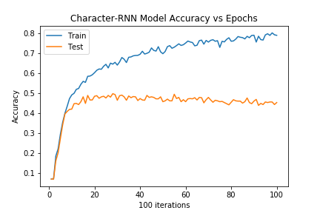

|  |  |  |
| --- | --- | --- |
|  | Dataset used | |
| Train | Test |
| Final accuracy | 0.791 | 0.454 |
| Final entropy loss | 0.578 | 2.67 |

Again, the network has **overfit** the training set, as the entropy loss on test data has diverged away from the minimum after nearly 20 epochs. The test accuracy of the model is also worse than the previous Word-CNN model, only reaching 0.454, which is about 0.05 higher than the Character-CNN model. This is a good indicator that the RNN model performs better than the CNN model in classifying paragraph title data or character/word data that is, by nature, temporal.

### Word RNN Classifier

The regular Word-CNN classifier outlined above is trained. Below is the classifier’s entropy cost, a plot of the training and test accuracy vs epoch number, and the final entropy costs and accuracies of the model:

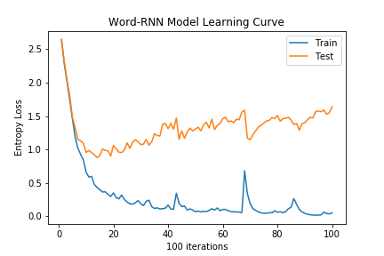 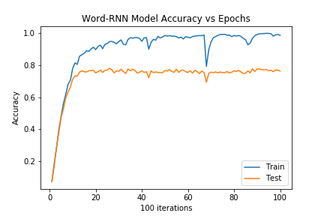

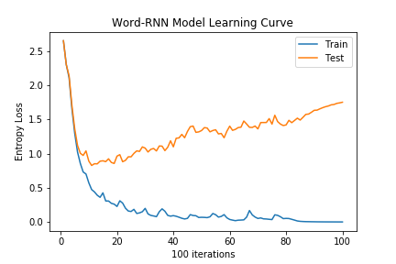 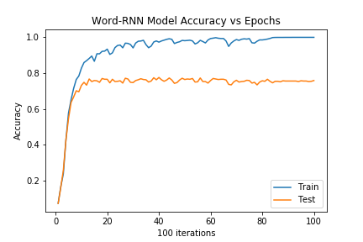

|  |  |  |
| --- | --- | --- |
|  | Dataset used | |
| Train | Test |
| Final accuracy | 1.0 | 0.759 |
| Final entropy loss | 0.00167 | 1.75 |

The entropy on test data still increases in the Word-RNN case, but it does not increase at an alarming rate, only increasing from slightly below 1 to 1.75. The Word-RNN also performs better than the previous three models, reaching a final test accuracy of 0.759. This shows that (1) encoding Wikipage paragraph data at the **word-level** is the best approach to pre-process the data before feeding it to the RNN and (2) an RNN network exploits the nature of the paragraph data much more effectively than a CNN network (for the reasons mentioned above in the Word-CNN classifier section (Section 2)).

### Comparing CNN and RNN Classifier Training Time and Adding Dropout to CNN and RNNs

#### Comparing Training Times

The training times for the 4 networks are visualized and mentioned below:

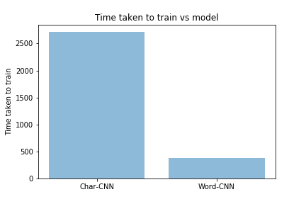 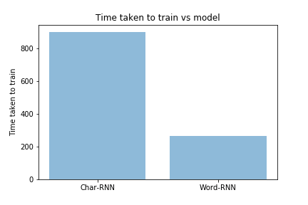

|  |  |  |  |
| --- | --- | --- | --- |
|  | | Encoding Level | |
| Character | Word |
| Network | CNN | 2900.3 | 402.1 |
| RNN | 900.7 | 265.2 |

Time taken to train in seconds for different models

Some patterns arise from these observed data:

1. Word-level encoded classifiers trained faster than character-level encoded classifiers.
   1. The character-CNN uses a 20 x 256 filter while the word-CNN uses a 20 x 20 filter in its first layer. Hence the character-CNN requires to update more parameters during training and hence training time for the character-CNN is more than that of the word-CNN.
   2. The input fed into the character-RNN at sequence = t has dimensions [1, 256], while for the word-RNN it is [1, 20]. Hence there are more parameters to train and update for the character-RNN (from the input layer to the hidden GRU layer) than for the word-RNN during backpropagation through time in mini-batch stochastic gradient descent.
2. Fixing the encoding level, RNNs train in a shorter time than CNNs. This could be presumably because the CNN has two layers and has 10 filters in each layer to train and update. Because of the CNN’s higher ‘relative complexity’ in terms of the number of parameters to train than the RNN, longer training times are needed for this CNN than this CNN’s corresponding RNN. However, if the RNN has, in general, the same number of parameters to train as the CNN, RNN training time would significantly take a much longer time due to its sequential parameter updating scheme using backpropagation through time (BPTT) (i.e.: Character-RNN taking a longer time to train than Word-CNN)

#### Adding Dropout to CNNs

The following are the entropy and accuracy plots of the Character and Word CNN when a dropout rate of 0.2 is applied to each conv-pool layer:

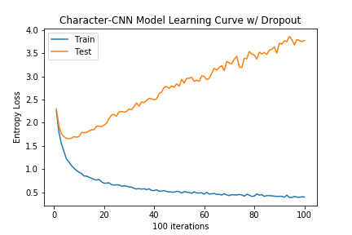 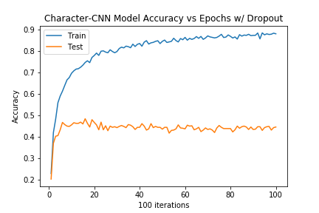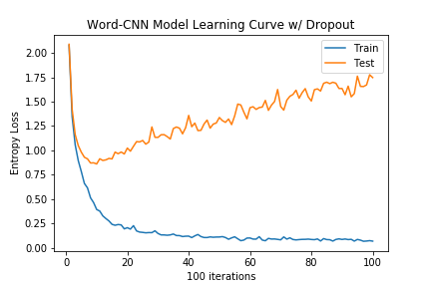 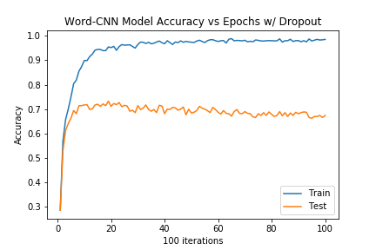

|  |  |  |  |  |
| --- | --- | --- | --- | --- |
|  | Char-CNN w/ out Dropout | Char-CNN with Dropout | Word-CNN w/ out Dropout | Word-CNN with Dropout |
| Final Training Accuracy | 0.974 | 0.879 | 0.999 | 0.985 |
| Final Test Accuracy | 0.404 | 0.444 | 0.709 | 0.674 |
| Final Training Loss | 0.0956 | 0.398 | 4.77 x 10-4 | 0.0677 |
| Final Test Loss | 10.3 | 3.77 | 3.61 | 1.75 |

As seen above, both the Character and Word CNNs with dropout applied to them would in general have **less** training accuracy and have **greater** entropy loss with training data. However, the Character and Word CNNs with dropout would have **greater** training accuracies and **less** entropy loss with test data than the Character and Word CNNs without dropout.

This is because dropout is a regularization technique to prevent overfitting of training data by not relying too much on certain features (some neurons are ‘dropped’ to reduce dependencies on this neuron during training). Hence both networks with dropout can fit the test dataset much better than those without dropout.

The only **exception** to this trend is the test accuracy for the Word-CNN with Dropout, which is 0.674, lower than 0.709, which is the test accuracy for the Word-CNN without Dropout. This is presumably because the network is allowed to train for 100 epochs and overfitting still occurs for the Word-CNN. Had early stopping been done, the test accuracy for the Word-CNN might have been higher with dropout than without. Another possible reason for this may be because the Word-CNN is already a relatively good-fit model (of its kind, of CNN), so regularizing using dropout did not affect the model result by much and instead made classification error even higher.

#### Adding Dropout to RNNs

The following are the entropy and accuracy plots of the Character and Word CNN when a dropout rate of 0.2 is applied to each conv-pool layer:

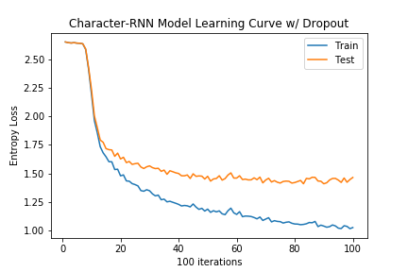 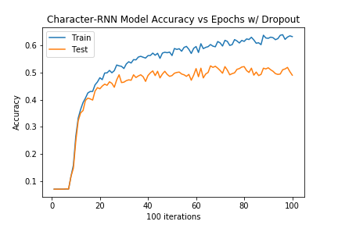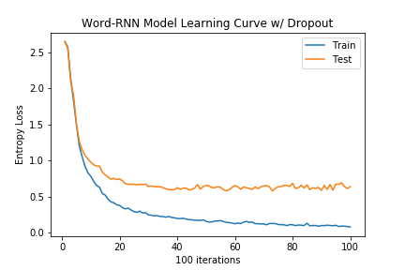 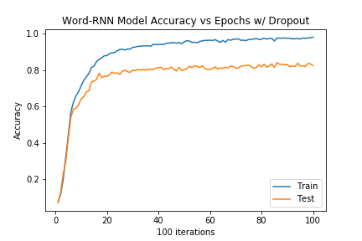

|  |  |  |  |  |
| --- | --- | --- | --- | --- |
|  | Char-RNN w/ out Dropout | Char-RNN with Dropout | Word-RNN w/ out Dropout | Word-RNN with Dropout |
| Final Training Accuracy | 0.791 | 0.632 | 1.0 | 0.980 |
| Final Test Accuracy | 0.454 | 0.490 | 0.759 | 0.824 |
| Final Training Loss | 0.578 | 1.02 | 0.00167 | 0.0801 |
| Final Test Loss | 2.67 | 1.46 | 1.75 | 0.640 |

Further figures were plotted in the next page to compare the RNN networks with and without dropout:

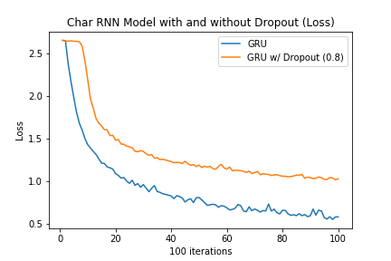 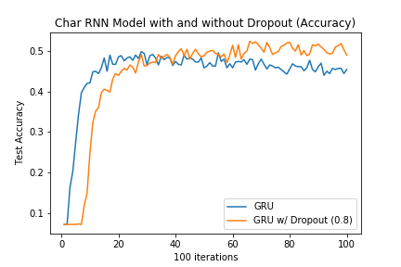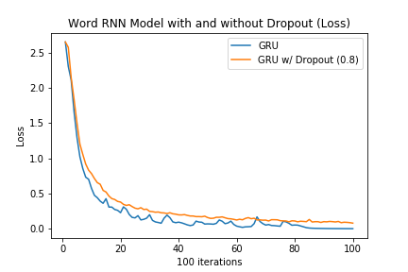 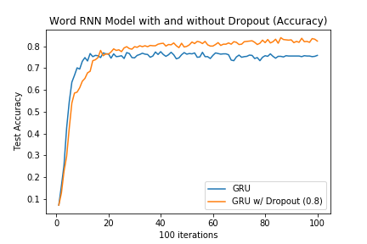

Again, from the figures above, both the Character and Word RNNs with dropout applied to them would in general have **less** training accuracy and have **greater** entropy loss with training data. However, these networks with dropout would have **greater** training accuracies and **less** entropy loss with test data than the Character and Word CNNs without dropout.

This is because dropout is a regularization technique to prevent overfitting of training data by not relying too much on certain features (some neurons are ‘dropped’ to reduce dependencies on this neuron during training). Hence both networks with dropout can fit the test dataset much better than those without dropout.

### Further Experiments with RNN Architectures

#### RNNs with Vanilla/LSTM cells vs GRU

##### Vanilla

The figures below show the results of replacing the Character and Word RNN cell type from GRU to Vanilla (BasicRNNCell from TensorFlow):

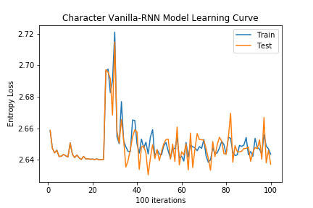 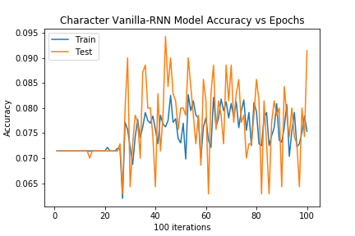 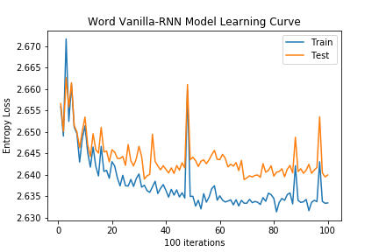 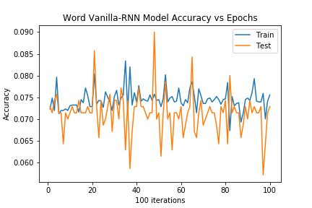

|  |  |  |  |  |
| --- | --- | --- | --- | --- |
|  | Char-RNN w/ GRU | Char-RNN w/ Vanilla | Word-RNN w/ GRU | Word-RNN w/ Vanilla |
| Final Training Accuracy | 0.791 | 0.0754 | 1.0 | 0.0755 |
| Final Test Accuracy | 0.454 | 0.0914 | 0.759 | 0.0729 |
| Final Training Loss | 0.578 | 2.64 | 0.00167 | 2.63 |
| Final Test Loss | 2.67 | 2.64 | 1.75 | 2.64 |

For both character and word RNNs, when the cell type layer is replaced to Vanilla, training and test accuracy does not significantly increase from its initial value at the beginning of training. Likewise, entropy for train and test data also does not significantly decrease as training progresses. The RNN architectures for Vanilla do not train until convergence after 100 epochs, hence the final accuracies (respectively entropy losses) of Vanilla Char-RNN are far lower (respectively far higher) than that of GRU Char-RNN.

This may be because convergence takes far more than 100 epochs. This could also be because of the Vanishing Gradient problem, where the RNN gradients vanish (there is no gate ‘memory’ in Vanilla RNN cells) up to zero and learning does not proceed.

##### LSTM

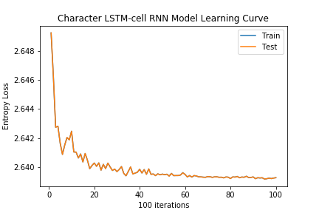 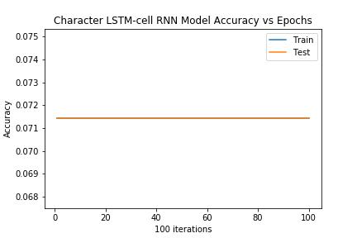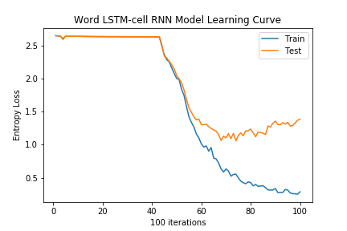 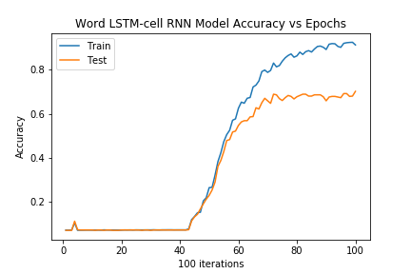

|  |  |  |  |  |
| --- | --- | --- | --- | --- |
|  | Char-RNN w/ GRU | Char-RNN w/ LSTM | Word-RNN w/ GRU | Word-RNN w/ LSTM |
| Final Training Accuracy | 0.791 | 0.0714 | 1.0 | 0.912 |
| Final Test Accuracy | 0.454 | 0.0714 | 0.759 | 0.701 |
| Final Training Loss | 0.578 | 2.64 | 0.00167 | 0.286 |
| Final Test Loss | 2.67 | 2.64 | 1.75 | 1.38 |

For the character-RNN, when the cell type layer is replaced to LSTM, training and test accuracy also does not significantly increse from its initial value. Likewise, entropy for train and test data does not significantly decrease as training progresses. The reason why the character-RNNs do not ‘learn’ is the same with that of the Vanilla RNNs mentioned above.

For the word-RNN, when the cell type layer is replaced to LSTM, learning can still happen after slightly more than 40 iterations, hence the vanishing gradient problem is overcome. The final test accuracy for LSTM word-RNN is 0.701, which is lower than that of GRU word-RNN at 0.759. Hence the GRU word-RNN still performs better than the LSTM word-RNN.

##### Overall verdict

More figures comparing the cell type used for the RNN are plotted below:

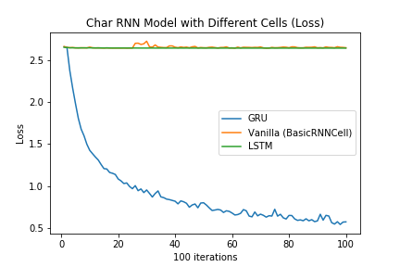 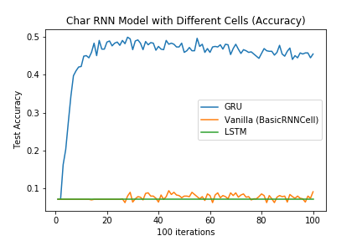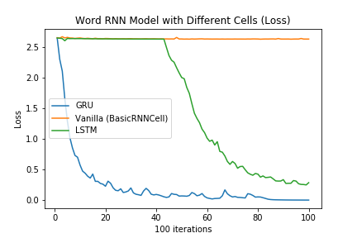 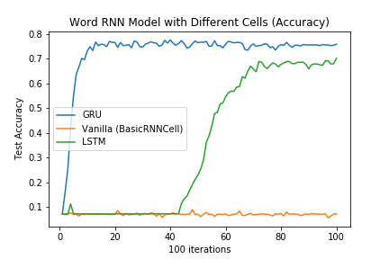

According to these figures, it is obvious that using GRU as the cell layer type is the best choice for the RNN model architecture, both at the character and word-level.

#### 1-layer vs 2-layer RNNs

The figures below show the results of using a 2-layer RNNs as compared to a 1-layer RNN:

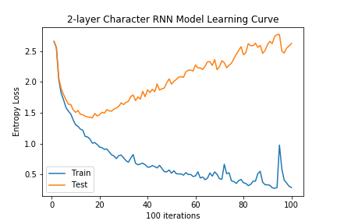 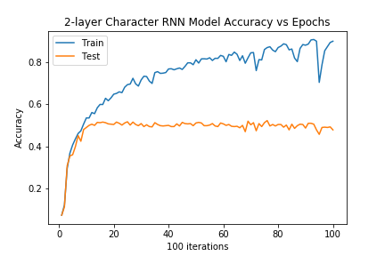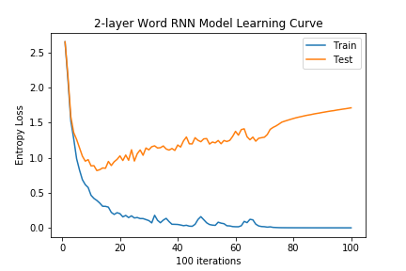 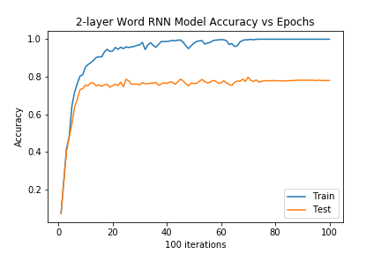

|  |  |  |  |  |
| --- | --- | --- | --- | --- |
|  | 1-layer Char-RNN | 2-layer Char-RNN | 1-layer Word-RNN | 2-layer Word-RNN |
| Final Training Accuracy | 0.791 | 0.901 | 1.0 | 1.0 |
| Final Test Accuracy | 0.454 | 0.479 | 0.759 | 0.780 |
| Final Training Loss | 0.578 | 0.291 | 0.00167 | 0.000438 |
| Final Test Loss | 2.67 | 2.62 | 1.75 | 1.71 |

According to the figures above, for both Character and Word RNNs, if the number of GRU layers increase from 1 to 2, the final test accuracy (respectively training loss) slightly increases (respectively slightly decreases). The 2-layer character RNN has a final test accuracy of 0.479, higher than its 1-layer counterpart at 0.454. Likewise, the 2-layer character RNN has a final test accuracy of 0.780, higher than its 1-layer counterpart at 0.759.

Hence the 2-layer RNNs are more accurate and fit the training dataset better than their 1-layer RNN counterparts. More figures to illustrate this are plotted in the next page:

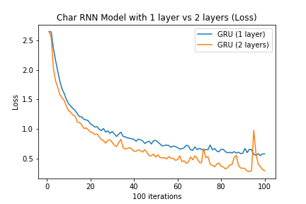 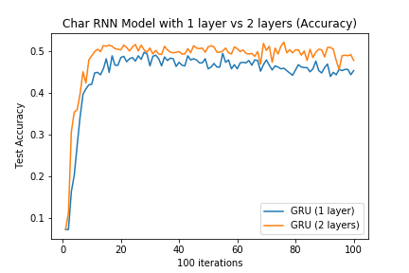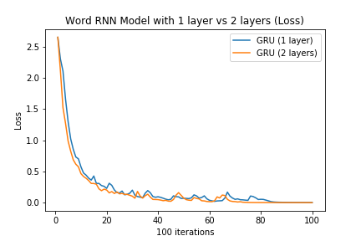 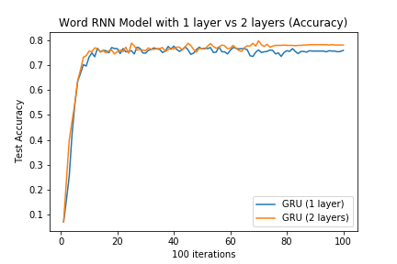

Hence 2-layer RNNs in this case are more preferred than their 1-layer RNN counterparts. This may be because the 2-layer RNNs can approximate more complex functions, and hence can fit the test dataset better as the network has not overfit yet. Albeit, the increase in test accuracy is not so significant, but its increase is regardless still there and can be seen in the figures.

#### RNNs with and without Gradient Clipping

The figures below show the results of using gradient clipping with threshold 2.0 as compared to if gradient clipping isn’t applied:

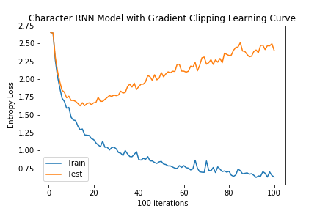 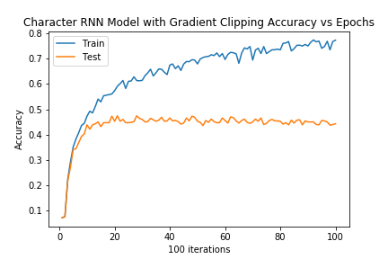

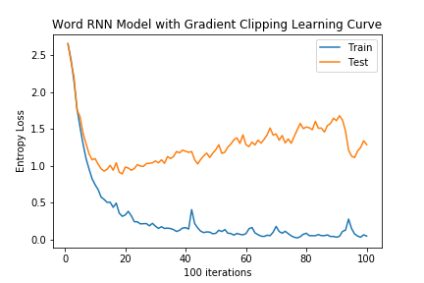 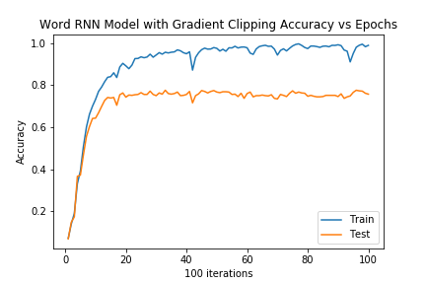

|  |  |  |  |  |
| --- | --- | --- | --- | --- |
|  | Char-RNN w/ out Gradient Clipping | Char-RNN w/ Gradient Clipping | Word-RNN w/ out Gradient Clipping | Word-RNN w/ Gradient Clipping |
| Final Training Accuracy | 0.791 | 0.773 | 1.0 | 0.989 |
| Final Test Accuracy | 0.454 | 0.443 | 0.759 | 0.757 |
| Final Training Loss | 0.578 | 0.629 | 0.00167 | 0.0503 |
| Final Test Loss | 2.67 | 2.40 | 1.75 | 1.29 |

More figures are plotted on the next page to compare the character and word RNNs with and without gradient clipping:

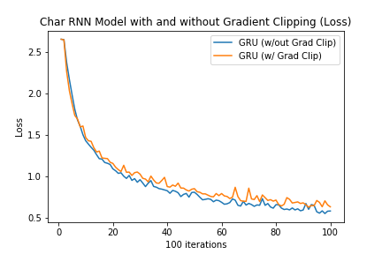 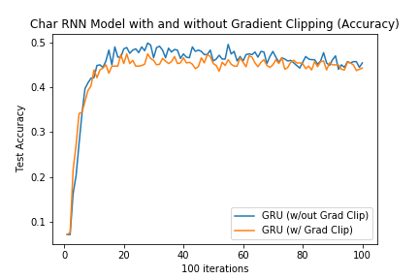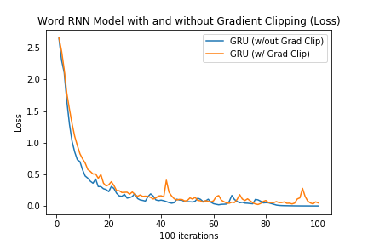 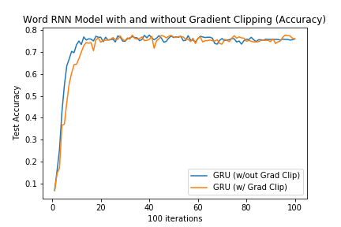

According to these four figures above, gradient clipping with a threshold of 2 does not seem to have a significant effect on the ‘speed to convergence’ of the model and does not have a significant effect on the model test accuracy both at the character level and the word level.

This may be because the optimization space does not have any sudden peaks or valleys that trap training in local minima, so whether gradient clipping is applied or not does not affect the where final ‘optima’ is that is reached by the model.

Clipping gradients at lower norms will also not affect the model test accuracy and rate of convergence (these experiments were tried afterwards, but this data was not recorded nor plotted).

## Conclusions

In this part-project, various CNN and RNN architectures were used to classify paragraph data and ‘categorize’ them, as well as the considerations (i.e.: RNN cell type used, encoding level for input, etc.) one should take to come up with a good model architecture to optimize model accuracy on test data.